



Implementation of data abstraction for a simple medical billing system in Python
LAB MANUAL

Disclaimer: The content is curated from online/offline resources and used for educational purpose only
Implementation of data abstraction for a simple medical billing system in Python

Objectives:
- To demonstrate data abstraction using an abstract base class and concrete subclasses in Python.
- To create a simple medical billing system that allows for the abstraction of bill-related operations using abstract methods.
- To implement a concrete class that extends the abstract class, providing real implementations for billing-related tasks.
- To show the separation of interface (abstract methods) and implementation (concrete methods) using Python's ABC module.

Problem Statement:
In a hospital or clinic, patient billing involves several tasks, such as retrieving the billing details and updating the bill based on new charges. To provide a flexible and reusable structure, we can use data abstraction through abstract classes and methods. This allows us to define common tasks that every billing system should perform, while allowing different implementations for different types of billing records.
Procedure:
Task 1: Define the Abstract Base Class
Task 2: Define the Concrete Class
Task 3: Use the Concrete Class

Code:
Task 1: Define the Abstract Base Class
In this step, we define the BillingRecord abstract base class (ABC), which contains two abstract methods:
get_bill() - To retrieve billing details.
update_bill() - To update the billing amount.
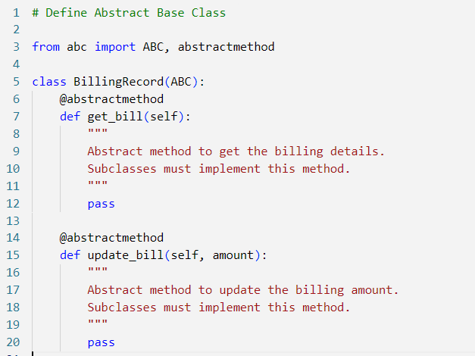

Task 2: Define the Concrete Class
get_bill(): This method retrieves and returns the current billing information for a patient, including their ID, name, and billing amount.
update_bill(): This method updates the billing amount by adding a positive charge. If the charge is valid (greater than 0), the billing amount is updated and displayed.
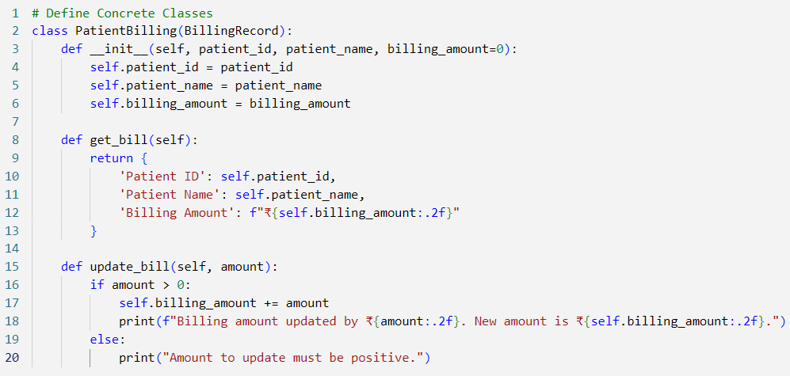

Task 3: Use the Concrete Class
Finally, we create an instance of the PatientBilling class, initialize it with sample data, and perform operations like displaying the bill and updating it.
A PatientBilling object is created with an initial billing amount of ₹150.00 for a patient named "Ramar Bose".
The initial billing details are retrieved using get_bill() and printed.
The billing amount is updated by ₹50.00 using update_bill().
Finally, the updated billing details are printed.

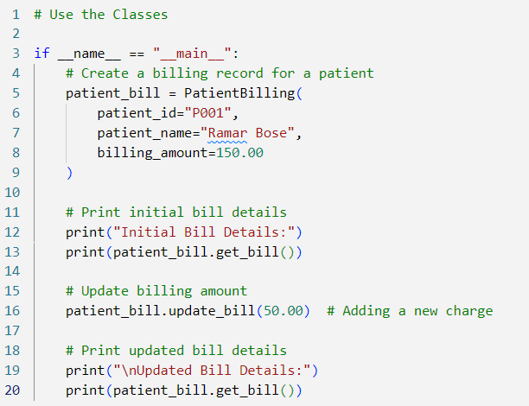

Output:
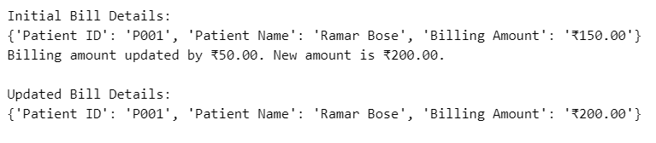
In this medical billing system, we demonstrated data abstraction using an abstract class that defines the core billing operations (get_bill() and update_bill()). The PatientBilling class provides a concrete implementation for patient-specific billing tasks, allowing flexible extension and reuse in other types of billing systems.

